Release of Medical Records Form

Patient’s Name: |  |  |  |  |  | Date of Birth:
Medical Record#: |  |  |  |  |  | Social Security #:
I hereby authorize:
Name:
Address:
City: |  | State: |  | Zip Code:

To release healthcare information of the patient named above to:
 | Name:
 | Address:
 | City: |  |  |  | State: |  |  |  |  |  | Zip Code:
 | Phone#: |  |  |  | Provider Fax #
Date & Time of Appointment __________________________________________________

PURPOSE OF DISCLOSURE:
All information regarding Alcohol and/or Drug Abuse will be released unless you restrict by initialing below:

_____ Do not release Alcohol/Drug info
Continuing Care
Payment of Claim
School
Worker’s Compensation
Legal
For Personal Use

Other (specify): ____________________________________________________________

INFORMATION TO BE RELEASED: Between Dates of: ________ to ___________

Discharge Summary X-ray reports HIV/AIDS test
H&P Exam X-ray films
Consult Diagnostic Tests
Progress Notes/Provider Notes Procedure reports
Orders Lab reports/pathology
Other (specify content and dates):

ACKNOWLEDGEMENT OF UNDERSTANDING:

- I understand the expiration date of this authorization is one year from today’s date.
- I understand that I may revoke this authorization at any time, in writing.
- I understand that information used or disclosed pursuant to this authorization may be subject to re-disclosure by the recipient and no longer be protected by Federal regulations.
- I understand that MPH may not condition my treatment, payment, enrollment or eligibility for benefits on my signing this authorization.

Patient Signature Date

Signature of Authorized Person Relationship to Patient

If you have questions, please contact Health Information Management at 970-724-3128. Please return release to Middle Park Health.
Email: CCulbreath@middleparkhealth.org Mail: PO BOX 399 C/O Medical Records, Kremmling, CO. 80459 Fax: 970-724-3211

Requesting Medical Records through MyChart

Navigate to MyChart (MyCenturaHealth) login and sign in. A link to can be found on Middle Park Health’s Website www.middleparkhealth.org under Patient Portal. If you do not have account, use the sign up now feature.

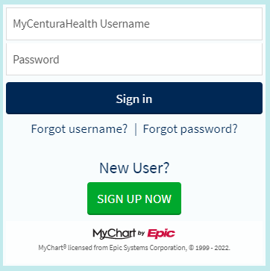

Once you are signed in navigate to the Menu tab and select. 

You will see the menu dropdown appear. Navigate to the section labeled “Document Center” and select.
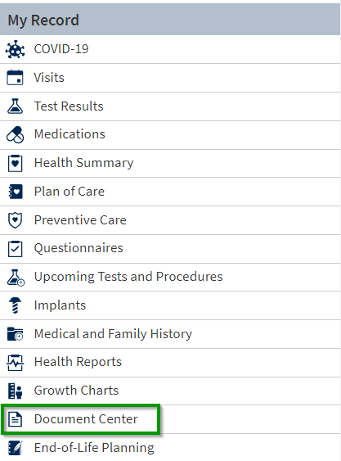

In Document Center you will be able to:
- Visit Records where you will be able to request records.
- View Requested Records.
- Sign, view, download and print documents you have on file from My Documents.
- Last, review who has accessed you records.

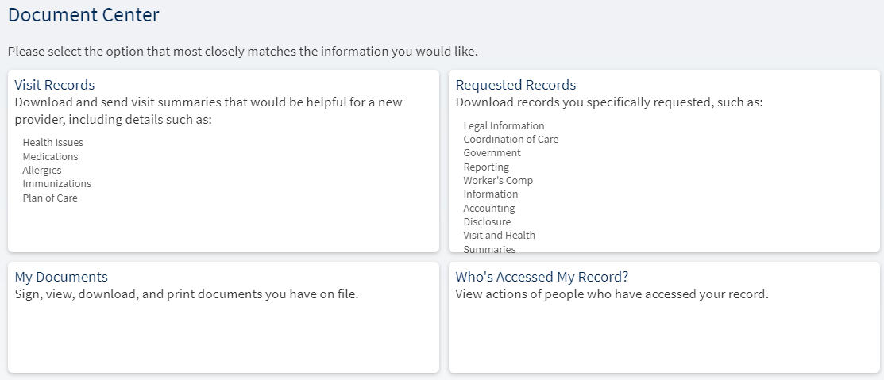

Under Visit Records, select the service to request Medical Records and download.

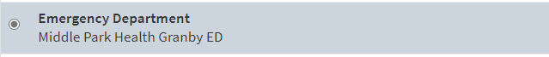

You will receive a notification (via text or email depending on your notification preferences) when your documents are ready to view in MyChart. The process to receive the records takes about 10 minutes to receive.

